Aneks 1.

TEHNIČKI USLOVI ZA KORIŠTENJE MULTIPLEKSA 1 za digitalni radio (DAB+)
Sadržaj
1 Geografska područja 2
1.1 Grafički prikaz i tabela testnih tačaka za digitalnu regiju PLJEŠEVICA 3
1.2 Grafički prikaz i tabela testnih tačaka za digitalnu regiju KOZARA 5
1.3 Grafički prikaz i tabela testnih tačaka za digitalnu regiju VLAŠIĆ 7
1.4 Grafički prikaz i tabela testnih tačaka za digitalnu regiju MAJEVICA 9
1.5 Grafički prikaz i tabela testnih tačaka za digitalnu regiju TUŠNICA 11
1.6 Grafički prikaz i tabela testnih tačaka za digitalnu regiju BJELAŠNICA 13
1.7 Grafički prikaz i tabela testnih tačaka za digitalnu regiju TROVRH 15
1.8 Grafički prikaz i tabela testnih tačaka za digitalnu regiju VELEŽ 17
1.9 Grafički prikaz i tabela testnih tačaka za digitalnu regiju LEOTAR 19
2 DAB+ radijski kanali 21
3 Minimalni nivo električnog polja za kvalitetan prijem 21
4 Standard kodiranja audiosignala 21
5 Brzine prijenosa 21
6 Tehnički standardi 22
7 Emisione lokacije s predajnicima velike snage 22

Geografska područja

Ukupno pokrivanje Bosne i Hercegovine postiže se s devet SFN mreža (SFN ‒ Single Frequency Network, mreže u kojima svi predajnici rade na istoj frekvenciji), po jedna za svaku od digitalnih regija. Granice digitalnih regija definirane su testnim tačkama. Testne tačke predstavljaju lokacije na kojima je planiran potrebni nivo električnog polja za kvalitetan prijem signala. Prikaz digitalnih regija dat je na narednoj slici.

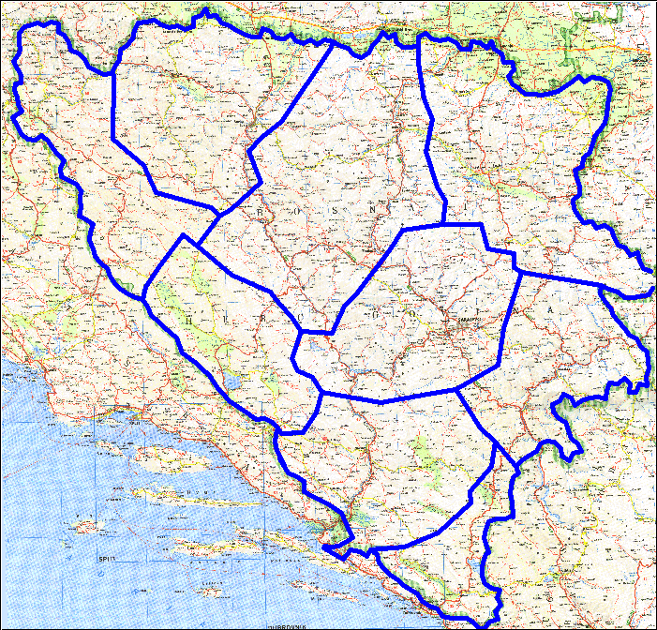

Grafički prikaz i tabela testnih tačaka za digitalnu regiju PLJEŠEVICA
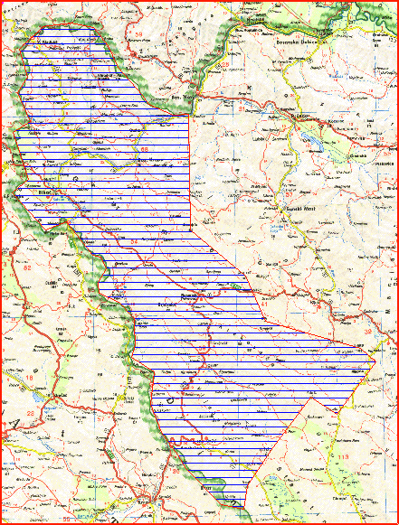

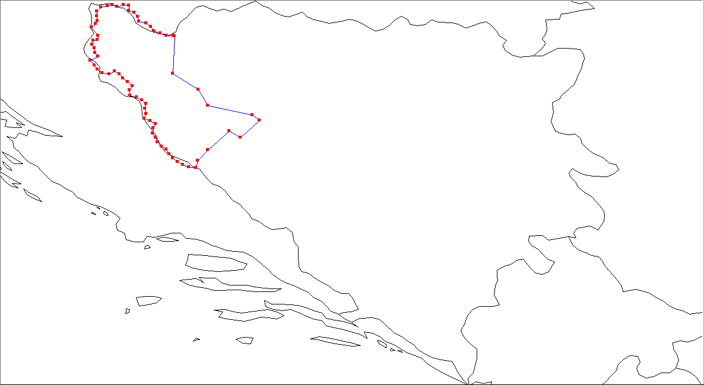

 | PLJEŠEVICA
0 | 016°21'08" E | 44°59'39" N
1 | 016°20'18" E | 44°43'08" N
2 | 016°31'29" E | 44°36'05" N
3 | 016°35'43" E | 44°29'08" N
4 | 016°55'27" E | 44°24'50" N
5 | 016°58'24" E | 44°22'36" N
6 | 016°50'06" E | 44°15'01" N
7 | 016°45'13" E | 44°17'54" N
8 | 016°35'45" E | 44°09'27" N
9 | 016°31'21" E | 44°04'42" N
10 | 016°30'23" E | 44°01'31" N
11 | 016°27'22" E | 44°01'53" N
12 | 016°24'49" E | 44°02'59" N
13 | 016°22'20" E | 44°04'13" N
14 | 016°20'13" E | 44°05'44" N
15 | 016°18'40" E | 44°07'35" N
16 | 016°17'29" E | 44°09'34" N
17 | 016°15'21" E | 44°11'06" N
18 | 016°13'24" E | 44°12'44" N
19 | 016°12'42" E | 44°14'51" N
20 | 016°11'29" E | 44°16'52" N
21 | 016°11'45" E | 44°19'03" N
22 | 016°12'43" E | 44°21'04" N
23 | 016°10'16" E | 44°22'18" N
24 | 016°07'38" E | 44°23'25" N
25 | 016°08'30" E | 44°25'29" N
26 | 016°08'02" E | 44°27'39" N
27 | 016°08'35" E | 44°29'48" N
28 | 016°06'43" E | 44°31'31" N
29 | 016°04'13" E | 44°32'38" N
30 | 016°01'30" E | 44°33'38" N
31 | 016°01'10" E | 44°35'46" N
32 | 016°02'24" E | 44°37'47" N
33 | 016°00'19" E | 44°39'26" N
34 | 015°58'22" E | 44°41'00" N
35 | 015°56'42" E | 44°42'50" N
36 | 015°54'32" E | 44°44'20" N
37 | 015°52'10" E | 44°43'03" N
38 | 015°49'12" E | 44°43'22" N
39 | 015°47'02" E | 44°44'56" N
40 | 015°45'37" E | 44°46'47" N
41 | 015°43'49" E | 44°48'58" N
42 | 015°47'15" E | 44°50'42" N
43 | 015°46'04" E | 44°52'22" N
44 | 015°45'38" E | 44°54'30" N
45 | 015°44'49" E | 44°56'09" N
46 | 015°45'05" E | 44°57'49" N
47 | 015°47'04" E | 44°58'08" N
48 | 015°47'18" E | 44°59'51" N
49 | 015°44'27" E | 45°03'42" N
50 | 015°46'20" E | 45°05'14" N
51 | 015°47'02" E | 45°06'30" N
52 | 015°46'41" E | 45°08'42" N
53 | 015°46'44" E | 45°10'48" N
54 | 015°48'36" E | 45°12'31" N
55 | 015°51'25" E | 45°13'03" N
56 | 015°53'39" E | 45°13'34" N
57 | 015°55'38" E | 45°12'52" N
58 | 015°58'27" E | 45°13'40" N
59 | 016°01'03" E | 45°13'15" N
60 | 016°01'00" E | 45°10'57" N
61 | 016°03'16" E | 45°10'13" N
62 | 016°04'56" E | 45°08'23" N
63 | 016°05'27" E | 45°06'20" N
64 | 016°08'29" E | 45°05'28" N
65 | 016°10'30" E | 45°03'48" N
66 | 016°11'59" E | 45°02'02" N
67 | 016°14'45" E | 45°00'54" N
68 | 016°17'29" E | 44°59'59" N
69 | 016°20'30" E | 45°00'03" N
70 | 016°21'08" E | 44°59'39" N

Grafički prikaz i tabela testnih tačaka za digitalnu regiju KOZARA
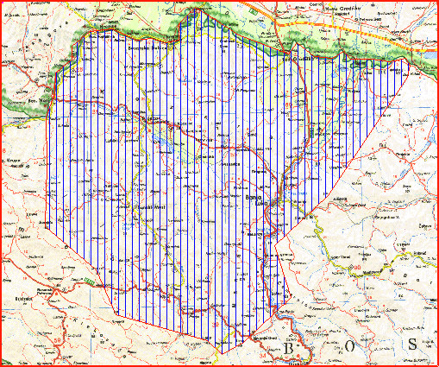

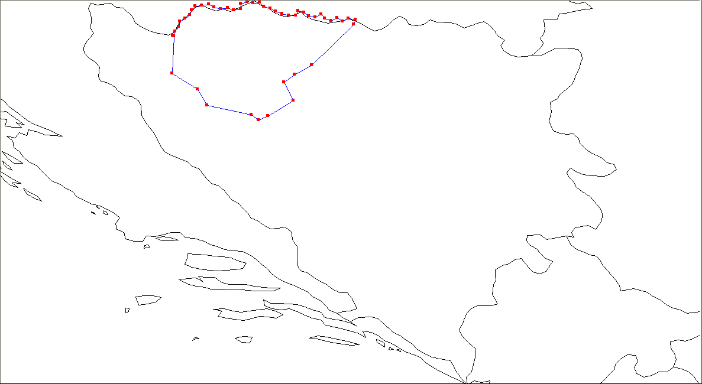

 | KOZARA
0 | 017°40'38" E | 45°05'00" N
1 | 017°22'03" E | 44°46'50" N
2 | 017°14'36" E | 44°42'46" N
3 | 017°09'47" E | 44°39'18" N
4 | 017°13'51" E | 44°31'04" N
5 | 017°02'40" E | 44°24'18" N
6 | 016°58'24" E | 44°22'36" N
7 | 016°55'27" E | 44°24'50" N
8 | 016°35'43" E | 44°29'08" N
9 | 016°31'29" E | 44°36'05" N
10 | 016°20'18" E | 44°43'08" N
11 | 016°21'08" E | 44°59'39" N
12 | 016°20'30" E | 45°00'03" N
13 | 016°21'39" E | 45°01'47" N
14 | 016°23'12" E | 45°03'52" N
15 | 016°23'35" E | 45°06'15" N
16 | 016°25'59" E | 45°07'29" N
17 | 016°28'07" E | 45°09'01" N
18 | 016°28'50" E | 45°11'16" N
19 | 016°30'23" E | 45°13'05" N
20 | 016°33'21" E | 45°13'19" N
21 | 016°36'24" E | 45°13'45" N
22 | 016°38'48" E | 45°12'29" N
23 | 016°41'47" E | 45°11'47" N
24 | 016°44'49" E | 45°12'12" N
25 | 016°47'37" E | 45°11'18" N
26 | 016°50'38" E | 45°11'48" N
27 | 016°50'34" E | 45°14'00" N
28 | 016°53'25" E | 45°14'48" N
29 | 016°55'20" E | 45°16'28" N
30 | 016°56'06" E | 45°14'23" N
31 | 016°59'07" E | 45°14'33" N
32 | 017°00'53" E | 45°12'48" N
33 | 017°03'43" E | 45°11'55" N
34 | 017°06'14" E | 45°10'38" N
35 | 017°08'57" E | 45°09'38" N
36 | 017°11'48" E | 45°08'51" N
37 | 017°14'54" E | 45°08'50" N
38 | 017°16'02" E | 45°10'52" N
39 | 017°18'42" E | 45°10'10" N
40 | 017°20'44" E | 45°08'32" N
41 | 017°23'46" E | 45°08'08" N
42 | 017°26'14" E | 45°09'22" N
43 | 017°27'52" E | 45°07'32" N
44 | 017°30'38" E | 45°06'37" N
45 | 017°33'16" E | 45°07'41" N
46 | 017°35'48" E | 45°06'21" N
47 | 017°38'26" E | 45°07'36" N
48 | 017°41'29" E | 45°07'04" N
49 | 017°40'38" E | 45°05'00" N

Grafički prikaz i tabela testnih tačaka za digitalnu regiju VLAŠIĆ
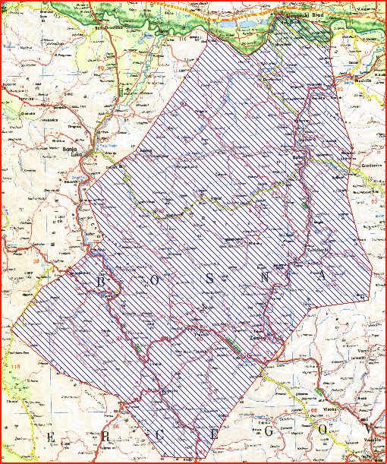

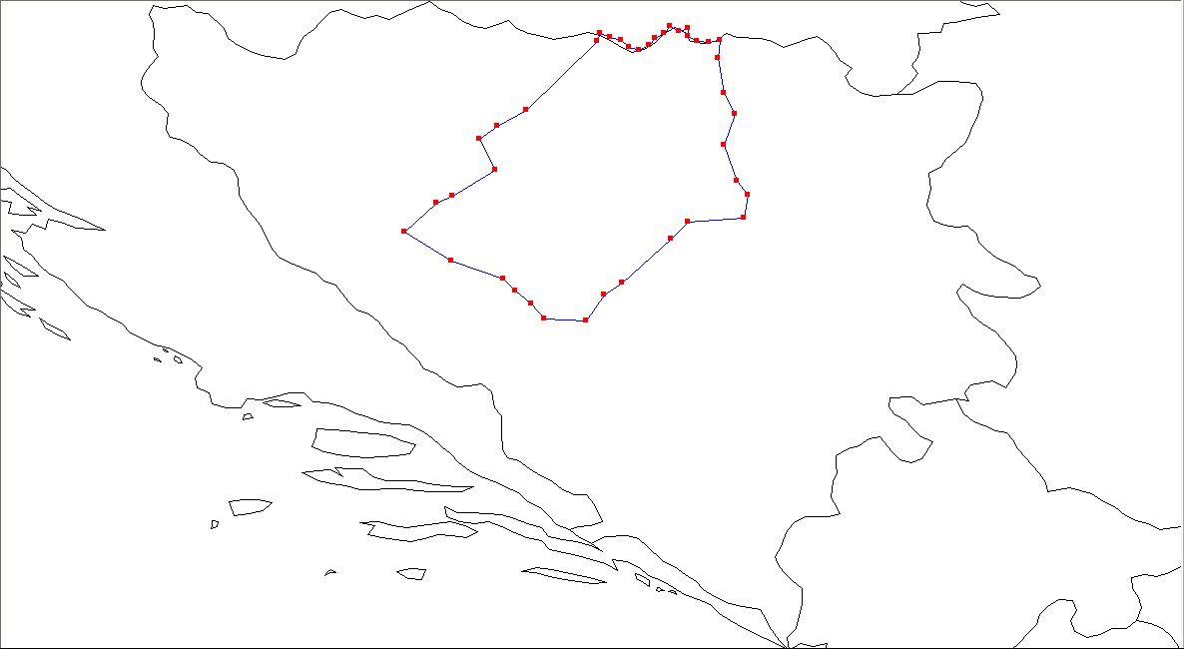

 | VLAŠIĆ
0 | 017°41'29" E | 45°07'04" N
1 | 017°44'07" E | 45°05'56" N
2 | 017°46'53" E | 45°05'04" N
3 | 017°48'58" E | 45°03'28" N
4 | 017°51'44" E | 45°02'40" N
5 | 017°54'21" E | 45°03'49" N
6 | 017°55'58" E | 45°05'40" N
7 | 017°58'15" E | 45°07'06" N
8 | 017°59'50" E | 45°08'59" N
9 | 018°02'02" E | 45°07'31" N
10 | 018°04'23" E | 45°08'26" N
11 | 018°04'36" E | 45°06'17" N
12 | 018°06'54" E | 45°04'53" N
13 | 018°09'58" E | 45°04'43" N
14 | 018°12'55" E | 45°05'19" N
15 | 018°12'20" E | 45°00'34" N
16 | 018°13'52" E | 44°51'24" N
17 | 018°16'44" E | 44°45'48" N
18 | 018°13'57" E | 44°37'47" N
19 | 018°17'21" E | 44°28'20" N
20 | 018°20'14" E | 44°24'41" N
21 | 018°19'03" E | 44°18'34" N
22 | 018°04'29" E | 44°17'28" N
23 | 018°00'03" E | 44°13'09" N
24 | 017°47'06" E | 44°01'32" N
25 | 017°42'24" E | 43°58'22" N
26 | 017°37'41" E | 43°51'30" N
27 | 017°26'53" E | 43°52'07" N
28 | 017°23'31" E | 43°55'58" N
29 | 017°19'15" E | 43°59'31" N
30 | 017°16'09" E | 44°02'40" N
31 | 017°02'28" E | 44°07'18" N
32 | 016°50'06" E | 44°15'01" N
33 | 016°58'24" E | 44°22'36" N
34 | 017°02'40" E | 44°24'18" N
35 | 017°13'51" E | 44°31'04" N
36 | 017°09'47" E | 44°39'18" N
37 | 017°14'36" E | 44°42'46" N
38 | 017°22'03" E | 44°46'50" N
39 | 017°40'38" E | 45°05'00" N
40 | 017°41'29" E | 45°07'04" N

Grafički prikaz i tabela testnih tačaka za digitalnu regiju MAJEVICA
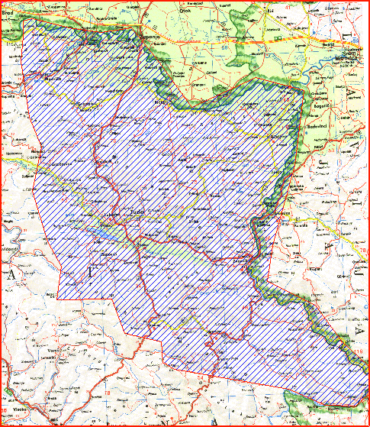

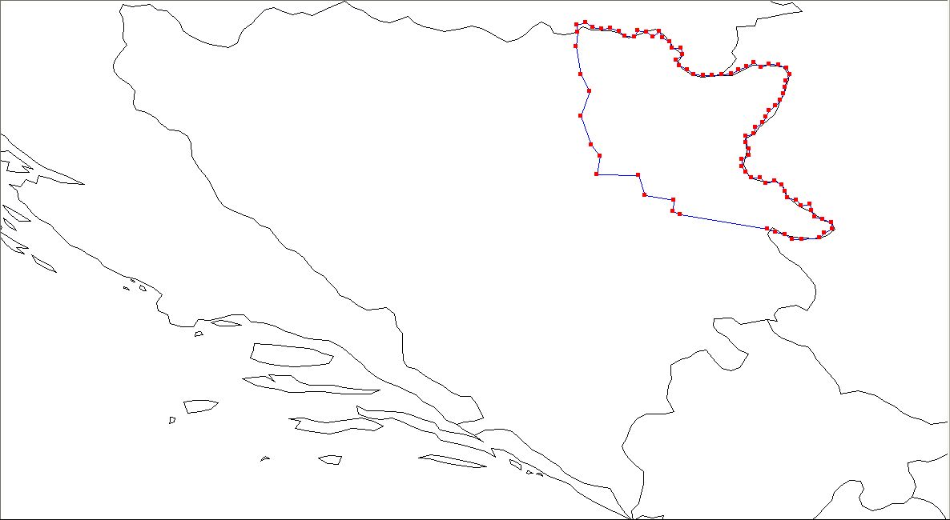

 | MAJEVICA
0 | 018°46'30" E | 44°05'24" N
1 | 018°44'06" E | 44°06'40" N
2 | 018°44'20" E | 44°10'13" N
3 | 018°34'58" E | 44°11'43" N
4 | 018°32'43" E | 44°18'13" N
5 | 018°19'03" E | 44°18'34" N
6 | 018°20'14" E | 44°24'41" N
7 | 018°17'21" E | 44°28'20" N
8 | 018°13'57" E | 44°37'47" N
9 | 018°16'44" E | 44°45'48" N
10 | 018°13'52" E | 44°51'24" N
11 | 018°12'20" E | 45°00'34" N
12 | 018°12'55" E | 45°05'19" N
13 | 018°12'42" E | 45°07'29" N
14 | 018°15'30" E | 45°08'23" N
15 | 018°17'43" E | 45°06'48" N
16 | 018°20'41" E | 45°06'14" N
17 | 018°23'42" E | 45°06'30" N
18 | 018°26'27" E | 45°05'30" N
19 | 018°28'26" E | 45°03'49" N
20 | 018°31'30" E | 45°03'40" N
21 | 018°32'28" E | 45°05'40" N
22 | 018°35'28" E | 45°05'12" N
23 | 018°37'36" E | 45°03'41" N
24 | 018°39'37" E | 45°05'20" N
25 | 018°40'31" E | 45°03'17" N
26 | 018°43'05" E | 45°02'04" N
27 | 018°43'44" E | 44°59'56" N
28 | 018°46'43" E | 44°59'53" N
29 | 018°47'10" E | 44°57'44" N
30 | 018°45'07" E | 44°56'08" N
31 | 018°46'11" E | 44°54'08" N
32 | 018°48'41" E | 44°52'52" N
33 | 018°50'54" E | 44°51'21" N
34 | 018°53'55" E | 44°51'10" N
35 | 018°56'58" E | 44°51'00" N
36 | 019°00'01" E | 44°51'18" N
37 | 019°03'03" E | 44°51'35" N
38 | 019°05'30" E | 44°52'53" N
39 | 019°08'04" E | 44°54'03" N
40 | 019°10'34" E | 44°55'17" N
41 | 019°12'46" E | 44°53'48" N
42 | 019°15'32" E | 44°54'46" N
43 | 019°18'34" E | 44°54'28" N
44 | 019°21'17" E | 44°53'28" N
45 | 019°22'09" E | 44°51'23" N
46 | 019°21'02" E | 44°49'21" N
47 | 019°20'40" E | 44°47'13" N
48 | 019°20'07" E | 44°45'06" N
49 | 019°19'12" E | 44°43'02" N
50 | 019°17'30" E | 44°41'12" N
51 | 019°15'29" E | 44°39'37" N
52 | 019°14'28" E | 44°37'34" N
53 | 019°13'16" E | 44°35'34" N
54 | 019°10'56" E | 44°34'10" N
55 | 019°10'28" E | 44°32'01" N
56 | 019°07'44" E | 44°31'08" N
57 | 019°07'58" E | 44°28'57" N
58 | 019°08'54" E | 44°26'56" N
59 | 019°08'48" E | 44°24'48" N
60 | 019°06'25" E | 44°23'29" N
61 | 019°06'34" E | 44°21'18" N
62 | 019°07'52" E | 44°19'20" N
63 | 019°09'37" E | 44°17'32" N
64 | 019°12'35" E | 44°17'28" N
65 | 019°14'22" E | 44°15'42" N
66 | 019°17'14" E | 44°16'24" N
67 | 019°19'43" E | 44°15'11" N
68 | 019°20'36" E | 44°13'08" N
69 | 019°21'35" E | 44°11'03" N
70 | 019°24'22" E | 44°10'14" N
71 | 019°25'48" E | 44°08'18" N
72 | 019°28'43" E | 44°08'54" N
73 | 019°29'17" E | 44°06'46" N
74 | 019°30'22" E | 44°04'45" N
75 | 019°33'06" E | 44°03'52" N
76 | 019°35'47" E | 44°02'59" N
77 | 019°36'03" E | 44°00'46" N
78 | 019°33'27" E | 43°59'36" N
79 | 019°31'49" E | 43°57'50" N
80 | 019°26'03" E | 43°57'27" N
81 | 019°23'00" E | 43°57'30" N
82 | 019°20'41" E | 43°58'55" N
83 | 019°17'27" E | 43°59'49" N
84 | 019°14'49" E | 44°00'53" N
85 | 018°46'30" E | 44°05'24" N

Grafički prikaz i tabela testnih tačaka za digitalnu regiju TUŠNICA

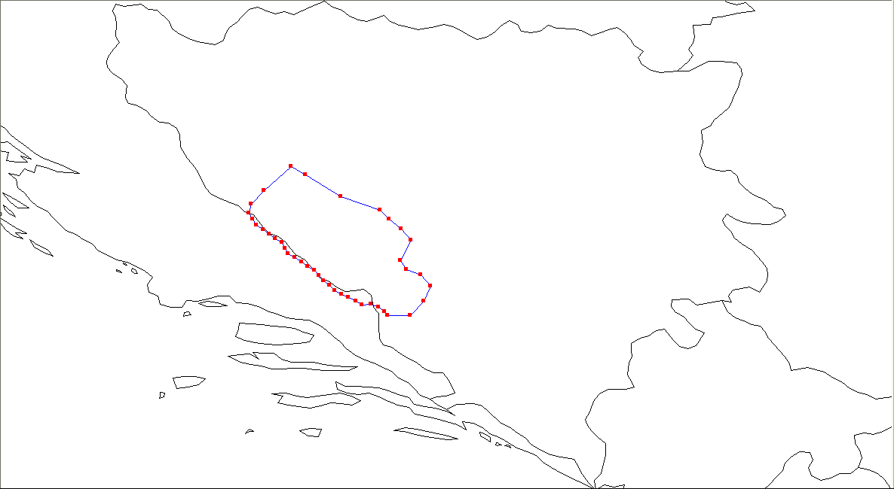

 | TUŠNICA
0 | 016°31'21" E | 44°04'42" N
1 | 016°35'45" E | 44°09'27" N
2 | 016°45'13" E | 44°17'54" N
3 | 016°50'06" E | 44°15'01" N
4 | 017°02'28" E | 44°07'18" N
5 | 017°16'09" E | 44°02'40" N
6 | 017°19'15" E | 43°59'31" N
7 | 017°23'31" E | 43°55'58" N
8 | 017°26'53" E | 43°52'07" N
9 | 017°23'14" E | 43°45'07" N
10 | 017°25'08" E | 43°42'03" N
11 | 017°30'16" E | 43°40'10" N
12 | 017°33'38" E | 43°36'09" N
13 | 017°31'18" E | 43°31'00" N
14 | 017°26'29" E | 43°25'56" N
15 | 017°18'33" E | 43°25'59" N
16 | 017°17'32" E | 43°27'23" N
17 | 017°15'29" E | 43°28'51" N
18 | 017°12'49" E | 43°29'46" N
19 | 017°09'51" E | 43°29'36" N
20 | 017°07'34" E | 43°31'02" N
21 | 017°05'10" E | 43°32'14" N
22 | 017°02'39" E | 43°33'24" N
23 | 017°00'15" E | 43°34'39" N
24 | 016°58'28" E | 43°36'25" N
25 | 016°56'20" E | 43°37'57" N
26 | 016°54'50" E | 43°39'53" N
27 | 016°53'10" E | 43°41'40" N
28 | 016°50'53" E | 43°43'04" N
29 | 016°48'52" E | 43°44'38" N
30 | 016°46'32" E | 43°46'00" N
31 | 016°44'06" E | 43°47'20" N
32 | 016°43'03" E | 43°49'22" N
33 | 016°41'59" E | 43°51'25" N
34 | 016°39'41" E | 43°52'47" N
35 | 016°37'34" E | 43°54'22" N
36 | 016°35'29" E | 43°55'54" N
37 | 016°33'09" E | 43°57'16" N
38 | 016°31'53" E | 43°59'25" N
39 | 016°30'23" E | 44°01'31" N
40 | 016°31'21" E | 44°04'42" N

Grafički prikaz i tabela testnih tačaka za digitalnu regiju BJELAŠNICA
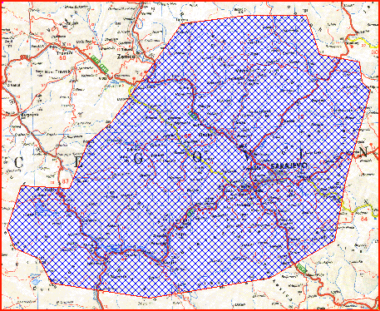

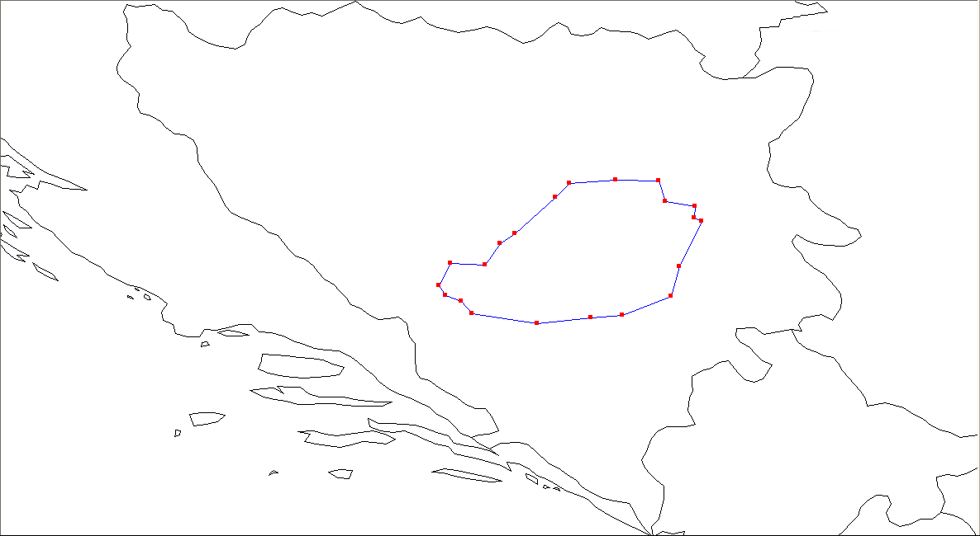

 | BJELAŠNICA
0 | 018°11'22" E | 43°34'52" N
1 | 017°54'15" E | 43°33'00" N
2 | 017°33'38" E | 43°36'09" N
3 | 017°30'16" E | 43°40'10" N
4 | 017°25'08" E | 43°42'03" N
5 | 017°23'14" E | 43°45'07" N
6 | 017°26'53" E | 43°52'07" N
7 | 017°37'41" E | 43°51'30" N
8 | 017°42'24" E | 43°58'22" N
9 | 017°47'06" E | 44°01'32" N
10 | 018°00'03" E | 44°13'09" N
11 | 018°04'29" E | 44°17'28" N
12 | 018°19'03" E | 44°18'34" N
13 | 018°32'43" E | 44°18'13" N
14 | 018°34'58" E | 44°11'43" N
15 | 018°44'20" E | 44°10'13" N
16 | 018°44'06" E | 44°06'40" N
17 | 018°46'30" E | 44°05'24" N
18 | 018°39'24" E | 43°51'06" N
19 | 018°36'49" E | 43°41'40" N
20 | 018°21'13" E | 43°35'47" N
21 | 018°11'22" E | 43°34'52" N

Grafički prikaz i tabela testnih tačaka za digitalnu regiju TROVRH
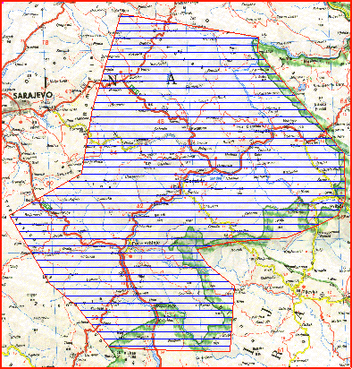

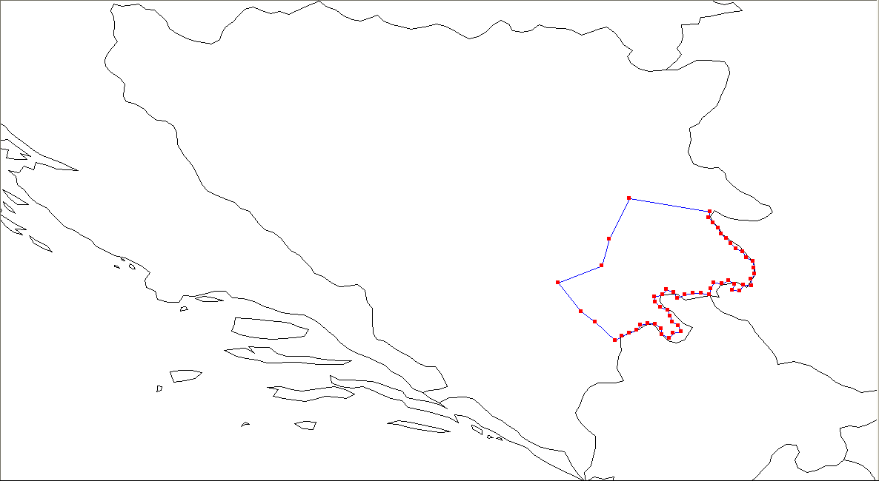

 | TROVRH
0 | 018°34'26" E | 43°21'42" N
1 | 018°29'15" E | 43°25'26" N
2 | 018°21'13" E | 43°35'47" N
3 | 018°36'49" E | 43°41'40" N
4 | 018°39'24" E | 43°51'06" N
5 | 018°46'30" E | 44°05'24" N
6 | 019°14'49" E | 44°00'53" N
7 | 019°14'31" E | 43°58'46" N
8 | 019°15'55" E | 43°56'49" N
9 | 019°17'42" E | 43°55'04" N
10 | 019°18'45" E | 43°53'01" N
11 | 019°20'40" E | 43°51'22" N
12 | 019°22'20" E | 43°49'34" N
13 | 019°24'11" E | 43°47'49" N
14 | 019°26'34" E | 43°46'33" N
15 | 019°27'48" E | 43°44'34" N
16 | 019°30'04" E | 43°43'08" N
17 | 019°30'22" E | 43°40'58" N
18 | 019°30'34" E | 43°38'47" N
19 | 019°29'14" E | 43°36'54" N
20 | 019°29'32" E | 43°34'29" N
21 | 019°26'38" E | 43°34'54" N
22 | 019°25'25" E | 43°32'53" N
23 | 019°22'49" E | 43°32'59" N
24 | 019°23'27" E | 43°35'07" N
25 | 019°21'31" E | 43°36'34" N
26 | 019°19'02" E | 43°35'20" N
27 | 019°16'06" E | 43°35'40" N
28 | 019°15'03" E | 43°33'41" N
29 | 019°14'39" E | 43°31'33" N
30 | 019°11'43" E | 43°32'06" N
31 | 019°08'46" E | 43°31'57" N
32 | 019°05'54" E | 43°31'28" N
33 | 019°03'27" E | 43°30'13" N
34 | 019°02'07" E | 43°32'11" N
35 | 018°59'35" E | 43°33'24" N
36 | 018°58'04" E | 43°31'32" N
37 | 018°55'22" E | 43°30'43" N
38 | 018°55'33" E | 43°28'48" N
39 | 018°57'21" E | 43°27'07" N
40 | 018°59'56" E | 43°26'03" N
41 | 019°00'45" E | 43°23'58" N
42 | 019°01'28" E | 43°21'52" N
43 | 019°03'40" E | 43°20'23" N
44 | 019°04'47" E | 43°18'22" N
45 | 019°01'52" E | 43°17'54" N
46 | 019°00'25" E | 43°16'02" N
47 | 018°57'55" E | 43°17'12" N
48 | 018°57'36" E | 43°19'21" N
49 | 018°55'36" E | 43°20'59" N
50 | 018°52'57" E | 43°21'22" N
51 | 018°50'18" E | 43°20'48" N
52 | 018°49'06" E | 43°18'48" N
53 | 018°46'26" E | 43°17'52" N
54 | 018°43'52" E | 43°16'49" N
55 | 018°41'17" E | 43°15'17" N
56 | 018°34'26" E | 43°21'42" N

Grafički prikaz i tabela testnih tačaka za digitalnu regiju VELEŽ
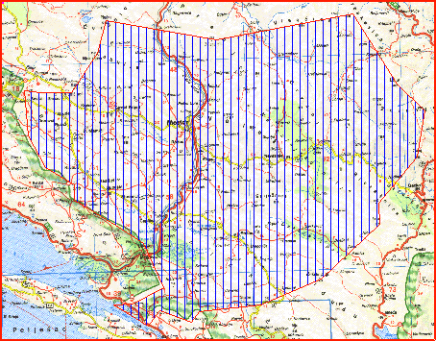

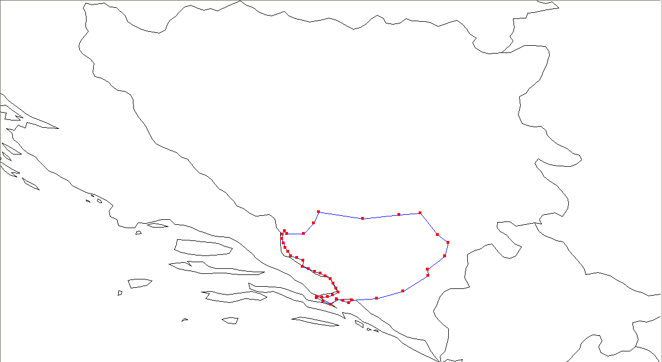

 | VELEŽ
0 | 017°18'33" E | 43°25'59" N
1 | 017°26'29" E | 43°25'56" N
2 | 017°31'18" E | 43°31'00" N
3 | 017°33'38" E | 43°36'09" N
4 | 017°54'15" E | 43°33'00" N
5 | 018°11'22" E | 43°34'52" N
6 | 018°21'13" E | 43°35'47" N
7 | 018°29'15" E | 43°25'26" N
8 | 018°34'26" E | 43°21'42" N
9 | 018°32'49" E | 43°15'33" N
10 | 018°24'42" E | 43°09'09" N
11 | 018°24'54" E | 43°06'17" N
12 | 018°13'06" E | 42°58'54" N
13 | 018°00'52" E | 42°55'33" N
14 | 017°48'58" E | 42°54'56" N
15 | 017°47'41" E | 42°53'28" N
16 | 017°45'13" E | 42°54'41" N
17 | 017°41'52" E | 42°55'15" N
18 | 017°39'21" E | 42°52'51" N
19 | 017°35'45" E | 42°54'20" N
20 | 017°32'34" E | 42°55'57" N
21 | 017°32'55" E | 42°56'24" N
22 | 017°35'10" E | 42°56'03" N
23 | 017°37'45" E | 42°56'21" N
24 | 017°40'16" E | 42°57'12" N
25 | 017°42'53" E | 42°58'22" N
26 | 017°41'41" E | 43°00'23" N
27 | 017°40'28" E | 43°02'34" N
28 | 017°39'11" E | 43°04'48" N
29 | 017°36'50" E | 43°06'03" N
30 | 017°34'24" E | 43°07'16" N
31 | 017°31'43" E | 43°08'15" N
32 | 017°28'53" E | 43°09'29" N
33 | 017°25'59" E | 43°10'38" N
34 | 017°26'09" E | 43°13'23" N
35 | 017°23'28" E | 43°14'36" N
36 | 017°20'33" E | 43°15'36" N
37 | 017°19'17" E | 43°17'36" N
38 | 017°17'46" E | 43°19'26" N
39 | 017°16'59" E | 43°21'33" N
40 | 017°16'26" E | 43°23'42" N
41 | 017°16'37" E | 43°25'36" N
42 | 017°17'32" E | 43°27'23" N
43 | 017°18'33" E | 43°25'59" N

Grafički prikaz i tabela testnih tačaka za digitalnu regiju LEOTAR
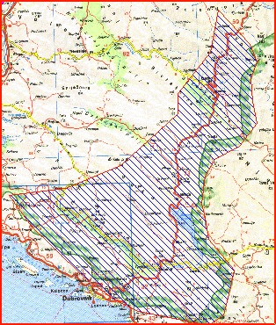

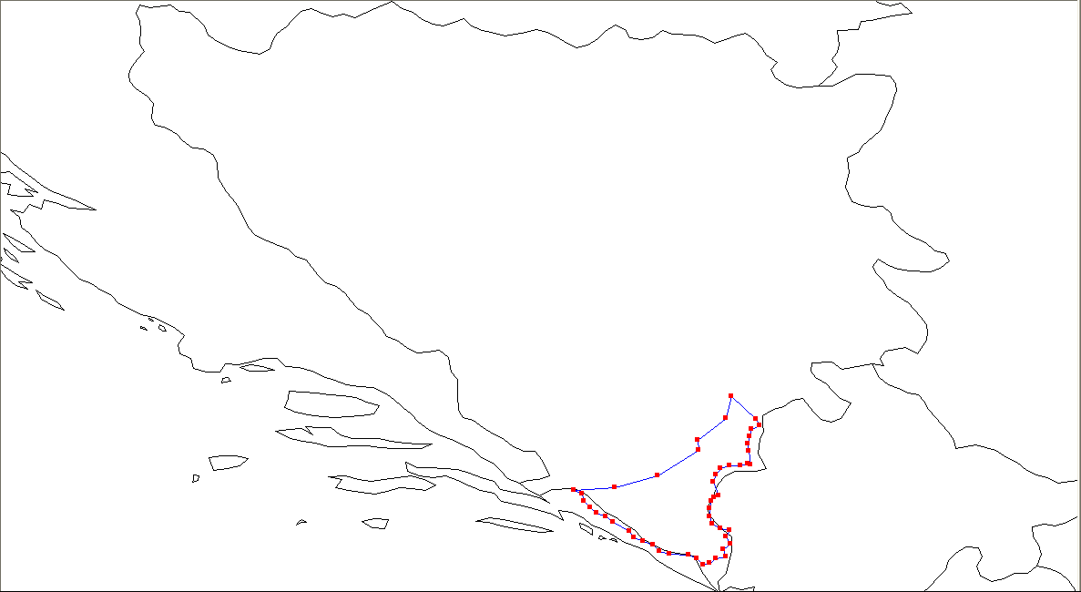

 | LEOTAR
0 | 018°00'52" E | 42°55'33" N
1 | 018°13'06" E | 42°58'54" N
2 | 018°24'54" E | 43°06'17" N
3 | 018°24'42" E | 43°09'09" N
4 | 018°32'49" E | 43°15'33" N
5 | 018°34'26" E | 43°21'42" N
6 | 018°41'17" E | 43°15'17" N
7 | 018°42'25" E | 43°13'28" N
8 | 018°40'07" E | 43°12'14" N
9 | 018°39'33" E | 43°10'13" N
10 | 018°39'04" E | 43°08'07" N
11 | 018°39'25" E | 43°06'00" N
12 | 018°39'46" E | 43°02'14" N
13 | 018°39'10" E | 43°02'17" N
14 | 018°36'55" E | 43°01'47" N
15 | 018°33'56" E | 43°01'51" N
16 | 018°31'04" E | 43°01'09" N
17 | 018°29'50" E | 42°59'12" N
18 | 018°29'12" E | 42°57'04" N
19 | 018°30'35" E | 42°53'10" N
20 | 018°29'25" E | 42°52'45" N
21 | 018°28'38" E | 42°51'34" N
22 | 018°28'04" E | 42°49'30" N
23 | 018°28'03" E | 42°47'21" N
24 | 018°28'43" E | 42°45'14" N
25 | 018°31'04" E | 42°43'55" N
26 | 018°33'53" E | 42°43'22" N
27 | 018°32'50" E | 42°41'22" N
28 | 018°34'04" E | 42°39'23" N
29 | 018°31'57" E | 42°37'50" N
30 | 018°32'51" E | 42°35'45" N
31 | 018°30'01" E | 42°35'16" N
32 | 018°28'04" E | 42°33'51" N
33 | 018°26'18" E | 42°33'23" N
34 | 018°24'24" E | 42°35'05" N
35 | 018°22'06" E | 42°36'20" N
36 | 018°16'28" E | 42°36'34" N
37 | 018°13'36" E | 42°37'10" N
38 | 018°11'44" E | 42°39'11" N
39 | 018°08'58" E | 42°40'04" N
40 | 018°06'27" E | 42°41'18" N
41 | 018°04'55" E | 42°43'08" N
42 | 018°00'11" E | 42°45'35" N
43 | 017°58'07" E | 42°47'06" N
44 | 017°55'35" E | 42°48'18" N
45 | 017°53'47" E | 42°49'56" N
46 | 017°51'49" E | 42°51'35" N
47 | 017°51'20" E | 42°53'42" N
48 | 017°48'58" E | 42°54'56" N
49 | 018°00'52" E | 42°55'33" N

DAB+ radijski kanali
Međunarodnim sporazumom i planom raspodjele frekvencija Ženeva 2006 određeni su frekvencijski resursi za zemaljski digitalni radio T-DAB.

Digitalna regija | Ukupna populacija | T-DAB kanal
PLJEŠEVICA | 230,434 | 11B
KOZARA | 497,337
VLAŠIĆ | 718,256 | 10A
MAJEVICA | 885,513 | 11C
BJELAŠNICA | 682,416 | 11B
TROVRH | 93,759 | 11D
TUŠNICA | 94,638 | 11C*
VELEŽ | 262,502
LEOTAR | 51,345
* privremena dodjela do stupanja na snagu plana Adriatic-Ionian grupe
Agencija zadržava pravo promjene kanala iz tabele gore (*), do stupanja na snagu Sporazuma Adriatic-Ionian grupe. U slučaju promjene kanala, Agencija će korisniku dozvole dodijeliti zamjenske kanale. Sve troškove vezane za zamjenu kanala snosi odabrani ponuđač – nosilac dozvole.

Minimalni nivo elektromagnetnog polja za kvalitetan prijem

Minimalna potrebna jačina električnog polja u tački prijema određuje se u skladu s ITU-R preporukama i odgovarajućim EBU tehničkim izvještajima, što odgovara elektromagnetnom polju od 58 dBμV/m na visini 10 m od tla.
Agencija će izračunavati predikciju pokrivanja prema statističkom modelu ITU-R P. 1546 i popisu stanovništva iz 2013. godine, kao postotak populacije koja može neometano primati signal. Stepen pokrivenosti procjenjuje se na osnovu konkretnih emisionih parametara za koje je Agencija izdala Dozvolu.

Standard za prijem audiosignala

Primijenjeni standardi trebaju biti u skladu s DAB+ normom (ETSI TS 102 563 V2.1.1 (2017-01), EBU Tech 3391).

Brzine prijenosa

Za kodiranje audiosignala koristi se AAC+ (High-Efficiency Advanced Audio Coding) kodek s korištenjem nivoa zaštite EEP 3-A. Koristan kapacitet multipleksa u ovom slučaju je maksimalno 1.5 Mbps, a prosječno 1152 kbps. Zauzetost multipleksa računa se preko jedinica za kapacitet (CU – Capacity Units), kojih ukupno ima 864.

Za različite vrste programa određene su brzine prijenosa koje odgovaraju vrsti programa i izražene su u kbps i CU.

Opis vrsta programa | Brzina prijenosa
Stereo audio (muzika Hi-Fi kvaliteta) | 96 kbps/72 CU
Stereo audio (muzički servis) | 64 kbps/48 CU
Stereo audio (govor/muzika) | 48 kbps/36 CU
Mono audio (muzički servis) | 48 kbps/36 CU
Mono audio (govor/muzika) | 32 kbps/24 CU
Servisni kanal (za obavještenja o stanju na cestama, vremenskoj prognozi i sl.) | 24 kbps/18 CU

Multipleks operater dužan je obezbijediti uslugu Programskog vodiča (EPG Electronic Program Guide) i za to obezbijediti protok od 16 kbps/12 CU za Packet data.

Tehnički propisi i standardi

Tehnički propisi i standardi definirani su članom 10. Pravila 90/2018 o pružanju usluga upravljanja elektronskim komunikacijskim mrežama u digitalnoj zemaljskoj radiodifuziji („Službeni glasnik BiH“, broj 92/18).

Emisione lokacije s predajnicima velike snage

U tabelama su navedene emisione lokacije predajnika veće snage za svaku digitalnu regiju s tehničkim parametrima koji su međunarodno koordinirani i za koje je potrebno dobiti dozvolu za korištenje radiofrekvencija. Matični predajnici mogu se instalirati i na drugim lokacijama u okviru neke digitalne regije, pod uslovom da tehnički parametri ostaju u skladu s okvirom koji pruža sporazum GE06.

Digitalna regija | Emisiona lokacija | Longituda | Latituda | Kanal | ERP  (dBW)
PLJEŠEVICA | Plješevica | 015°45'21" E | 44°47'14" N | 11B | 37
KOZARA | Lisina | 016°58'37" E | 44°58'21" N | 11B | 37
VLAŠIĆ | Paljenik | 017°38'10" E | 44°17'38" N | 10A | 40
MAJEVICA | Busija | 018°50'41" E | 44°33'56" N | 11C | 37
TUŠNICA | Vitrenik | 017°05'44" E | 43°43'21" N | 11C | 37
BJELAŠNICA | Bjelašnica | 018°15'25" E | 43°42'14" N | 11B | 37
TROVRH | Hadžića brdo | 018°51'44" E | 43°42'44" N | 11D | 37
VELEŽ | Hrgud | 018°01'40" E | 43°05'56" N | 11C | 37
LEOTAR | Leotar | 018°20'30" E | 42°44'51" N | 11C | 37

Napomena: Frekvencijski resursi koji se trenutno koriste za analognu zemaljsku radiodifuziju u istom opsegu u određenom području, a mogu biti izvor neželjenih smetnji, bit će oslobođeni kada multipleks operater obavijesti Agenciju o datumu početka rada u tom području. Agencije će poduzeti potrebne radnje u cilju neometanog rada multipleks operatera.

Tabelarni prikaz horizontalnih dijagrama zračenja (slabljenje zračenja energije u azimutu po 10°)
Plješevica 11B
Azimut  (°) | Atenuacija  (dB) | Azimut  (°) | Atenuacija  (dB) | Azimut  (°) | Atenuacija  (dB) | Azimut  (°) | Atenuacija  (dB)
0 | 0 | 90 | 0 | 180 | 10 | 270 | 10
10 | 0 | 100 | 0 | 190 | 10 | 280 | 10
20 | 0 | 110 | 0 | 200 | 10 | 290 | 10
30 | 0 | 120 | 0 | 210 | 10 | 300 | 10
40 | 0 | 130 | 0 | 220 | 10 | 310 | 10
50 | 0 | 140 | 10 | 230 | 10 | 320 | 10
60 | 0 | 150 | 10 | 240 | 10 | 330 | 0
70 | 0 | 160 | 10 | 250 | 10 | 340 | 0
80 | 0 | 170 | 10 | 260 | 10 | 350 | 0

Lisina 11B
Azimut  (°) | Atenuacija  (dB) | Azimut  (°) | Atenuacija  (dB) | Azimut  (°) | Atenuacija  (dB) | Azimut  (°) | Atenuacija  (dB)
0 | 3 | 90 | 0 | 180 | 0 | 270 | 0
10 | 3 | 100 | 0 | 190 | 0 | 280 | 0
20 | 3 | 110 | 0 | 200 | 0 | 290 | 0
30 | 3 | 120 | 0 | 210 | 0 | 300 | 0
40 | 0 | 130 | 0 | 220 | 0 | 310 | 0
50 | 0 | 140 | 0 | 230 | 0 | 320 | 0
60 | 0 | 150 | 0 | 240 | 0 | 330 | 0
70 | 0 | 160 | 0 | 250 | 0 | 340 | 3
80 | 0 | 170 | 0 | 260 | 0 | 350 | 3

Paljenik 10A
Azimut  (°) | Atenuacija  (dB) | Azimut  (°) | Atenuacija  (dB) | Azimut  (°) | Atenuacija  (dB) | Azimut  (°) | Atenuacija  (dB)
0 | 0 | 90 | 0 | 180 | 3 | 270 | 0
10 | 0 | 100 | 0 | 190 | 3 | 280 | 0
20 | 0 | 110 | 0 | 200 | 3 | 290 | 0
30 | 0 | 120 | 0 | 210 | 3 | 300 | 0
40 | 3 | 130 | 0 | 220 | 3 | 310 | 0
50 | 3 | 140 | 0 | 230 | 3 | 320 | 0
60 | 3 | 150 | 0 | 240 | 0 | 330 | 0
70 | 0 | 160 | 0 | 250 | 0 | 340 | 0
80 | 0 | 170 | 0 | 260 | 0 | 350 | 0

Busija 11C
ND

Vitrenik 11C
ND

Bjelašnica 11B
Azimut  (°) | Atenuacija  (dB) | Azimut  (°) | Atenuacija  (dB) | Azimut  (°) | Atenuacija  (dB) | Azimut  (°) | Atenuacija  (dB)
0 | 0 | 90 | 3 | 180 | 0 | 270 | 0
10 | 0 | 100 | 3 | 190 | 0 | 280 | 0
20 | 0 | 110 | 3 | 200 | 0 | 290 | 0
30 | 0 | 120 | 3 | 210 | 0 | 300 | 0
40 | 0 | 130 | 3 | 220 | 0 | 310 | 0
50 | 0 | 140 | 0 | 230 | 0 | 320 | 0
60 | 3 | 150 | 0 | 240 | 0 | 330 | 0
70 | 3 | 160 | 0 | 250 | 0 | 340 | 0
80 | 3 | 170 | 0 | 260 | 0 | 350 | 0

Hadžića brdo 11D
ND

Hrgud 11C
ND

Leotar 11C
ND

